**Background:**

In order to study the interactive effects of burn severity in two wildfire events (Storrie Fire and Chips Fire) on species composition, we surveyed the mid-story across a gradient of severity combinations in a short-interval reburn area in northern California. Using these data, we asked the following questions: 1) were there compositional shifts in the mid-story across severity combinations? 2) did certain species drive these changes? 3) are particular severity combinations selecting for certain fire-adaptive traits? We hypothesized that differences in species’ regeneration strategies would influence species assemblages following short-interval reburn along a gradient of burn severities.

**Study design:**

91 plots in 16 burn severity category combinations: unburned/unburned, low/moderate, high/high, etc. Generally 6 plots in each combination (some plots were eliminated due to lack of common species)

Predictor variables:

Chips Fire burn severity (RdNBR) – continuous

Storrie Fire burn severity (RdNBR) – continuous

Combined burn severity – categorical (low/low, moderate/high, etc.)

Other environmental:

Elevation

Aspect

Slope

Response variables:

Matrix of relative percent cover of common mid-story species (shrubs and seedlings/saplings)

# Data analysis:

**Indicator species analysis (Dufrêne and Legendre 1997)**

**NMDS ordination**

**Vectors of predictor variables added using envfit in R**

**How to extract effect size of each fire?**

**PERMANOVA of effect of continuous fire severity indice (RdNBR) for each fire on species composition**

**How to analyze interaction of two fires?**

**Other options: Pearson’s R correlation of NMS scores with predictor variables**

**Joint plot**

**Code:**

**#necessary packages**

**library(tidyverse)**

**library(vegan)**

**library(indicspecies)**

**library(labdsv)**

**#data frame of response variables (all common species Relative cover values) = coverRel.csv**

**cover2 <- read.table(file.choose(), T)**

**# dataframe of predictor variables (rdnbr, plot names & categories) = cover1.csv**

**cover <- read.table(file.choose(), T)**

**# dominant species for each plot = cdomin.csv**

**dom <- read.table(file.choose(), T)**

**#creates vector of storrie/chips severity combination**

**cat <- as.factor(cover$SC)**

**###############################################**

**#indicator species analysis using severity combinations**

**cov.ind <- multipatt(cover2, cluster = cat, control = how(nperm = 999), duleg = T)**

**summary(cov.ind, indvalcomp = T)**

**###############################################################**

**#creates NMDS ordination**

**z <- metaMDS(comm = cover2, k=3, distance = "horn", weakties=T, trymax = 100, autotransform = FALSE)**

**z$stress #.079**

**###########**

**#rotate NMDS by storrie severity####**

**z.sev <- MDSrotate(z, cover$storrie_rdnbr)**

**#plot**

**plot(z.sev, display = "sites")**

**#code points by dominant species**

**cols <- rainbow(12)**

**palette(col.rainbow)**

**points(z.sev$points, bg=dom$abun, pch=21, cex=1.3)**

**text(.1,.5, "CEIN", cex=1.2, col="black")**

**text(.5,-.7, "CECO", cex=1.2, col="black")**

**text(-.5,-.75, "ABCO/QUKE", cex=1.2, col="black")**

**title(main = "NMS with dominant species providing color coding")**

**#add continuous severity vectors**

**sev.fit <- envfit(z.sev ~ storrie_rdnbr + chips_rdnbr , data=cover, na.rm=T)**

**#aspect and elevation were not signif**

**#overlays vectors onto rotated nmds**

**plot(sev.fit)**

**sev.fit$vectors**

**# add circles around clusters of points**

**library(plotrix)**

**draw.ellipse(-.1, .6, a=.5, b=.25, border = "black", lwd=2) #cein**

**draw.ellipse(.75, -.75, a=.5, b=.18, border = "black", lwd=2) #ceco**

**draw.ellipse(-.6, -.85, a=.7, b=.2, border = "black", lwd=2) #abco/quke**

**#####################################################**

# ****Results****

Indicator species analysis:

Multilevel pattern analysis

---------------------------

Association function: IndVal.g

Significance level (alpha): 0.05

Total number of species: 12

Selected number of species: 6

Number of species associated to 1 group: 6

List of species associated to each combination:

Group high/high #sps. 1

A B stat p.value Indicator Value

**CECO 0.2258 0.8333 0.434 0.018 * 18**

Group high/un #sps. 1

A B stat p.value

CEVE 0.5361 0.1667 0.299 0.805

Group low/low #sps. 2

A B stat p.value

**QUKE 0.4423 1.0000 0.665 0.001 *** 44**

CEPR 0.4685 0.3333 0.395 0.603

Group mod/low #sps. 1

A B stat p.value

**PILA 0.3836 0.6667 0.506 0.043 * 26**

Group mod/un #sps. 2

A B stat p.value

ARPA 0.3472 0.5000 0.417 0.236

PIPO 0.7462 0.1667 0.353 0.898

Group un/low #sps. 2

A B stat p.value

RIRO 0.2853 0.6000 0.414 0.360

SYMO 0.3719 0.4000 0.386 0.241

Group un/mod #sps. 1

A B stat p.value

**CEIN 0.1391 1.0000 0.373 0.002 ** 14**

Group un/un #sps. 2

A B stat p.value

**PSME 0.8800 0.5000 0.663 0.013 * 44**

**ABCO 0.4128 0.7500 0.556 0.013 * 31**

---

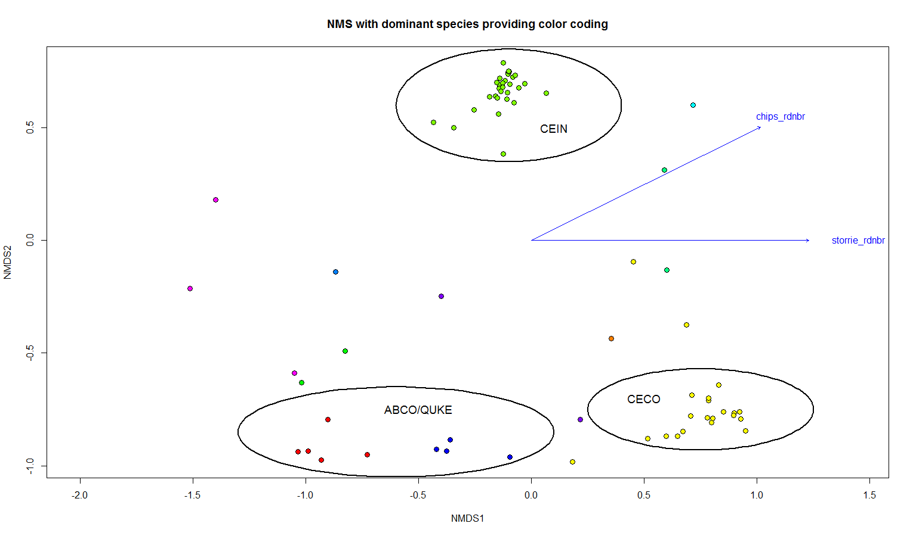

Permanova examining influence of continuous severity on species matrix:

Call:

adonis(formula = cover2 ~ cover$storrie_rdnbr * cover$chips_rdnbr)

Permutation: free

Number of permutations: 999

Terms added sequentially (first to last)

Df SumsOfSqs MeanSqs F.Model R2 Pr(>F)

cover$storrie_rdnbr 1 2.1334 2.13336 7.6264 0.07180 0.001 ***

cover$chips_rdnbr 1 1.9175 1.91751 6.8548 0.06453 0.001 ***

cover$storrie_rdnbr:cover$chips_rdnbr 1 1.3260 1.32597 4.7401 0.04462 0.002 **

Residuals 87 24.3368 0.27973 0.81904

Total 90 29.7136 1.00000

---

Signif. codes: 0 ‘***’ 0.001 ‘**’ 0.01 ‘*’ 0.05 ‘.’ 0.1 ‘ ’ 1

Nesting Storrie severity inside of Chips severity:

Call:

adonis(formula = cover2 ~ chip + sto %in% chip)

Permutation: free

Number of permutations: 999

Terms added sequentially (first to last)

Df SumsOfSqs MeanSqs F.Model R2 Pr(>F)

chip 1 2.0786 2.07860 7.0957 0.06995 0.001 ***

chip:sto 1 1.8564 1.85642 6.3372 0.06248 0.002 **

Residuals 88 25.7786 0.29294 0.86757

Total 90 29.7136 1.00000

---

Signif. codes: 0 ‘***’ 0.001 ‘**’ 0.01 ‘*’ 0.05 ‘.’ 0.1 ‘ ’ 1

Permanova using categories:

cover.sub$Storrie [cover.sub$Storrie==1] <- "un"

cover.sub$Storrie [cover.sub$Storrie==2] <- "un"

cover.sub$Storrie [cover.sub$Storrie==3] <- "burn"

cover.sub$Storrie [cover.sub$Storrie==4] <- "burn"

cover.sub$Chips [cover.sub$Chips==1] <- "un"

cover.sub$Chips [cover.sub$Chips==2] <- "un"

cover.sub$Chips [cover.sub$Chips==3] <- "burn"

cover.sub$Chips [cover.sub$Chips==4] <- "burn"

Df SumsOfSqs MeanSqs F.Model R2 Pr(>F)

cover$SC 3 3.5616 1.1872 3.9494 0.11986 0.002 **

Residuals 87 26.1521 0.3006 0.88014

Total 90 29.7136 1.00000

---

Signif. codes: 0 ‘***’ 0.001 ‘**’ 0.01 ‘*’ 0.05 ‘.’ 0.1 ‘ ’ 1

> pairwiseAdonis::pairwise.adonis(cover2, cover$SC)

pairs total.DF F.Model R2 p.value p.adjusted sig

1 un/un vs un/burn 43 6.370519 0.13170251 0.001 0.006 *

2 un/un vs burn/un 44 4.474322 0.09424721 0.002 0.012 .

3 un/un vs burn/burn 43 7.466112 0.15093388 0.001 0.006 *

4 un/burn vs burn/un 46 1.517177 0.03261541 0.182 1.000

5 un/burn vs burn/burn 45 2.172601 0.04705389 0.126 0.756

6 burn/un vs burn/burn 46 1.161172 0.02515473 0.290 1.000

In this model, unburned and burned once are significant, and unburned and burned twice are significant, but burned once vs. burned twice are not.

Categories:

cover.sub$Storrie [cover.sub$Storrie==1] <- "un"

cover.sub$Storrie [cover.sub$Storrie==2] <- "low"

cover.sub$Storrie [cover.sub$Storrie==3] <- "low"

cover.sub$Storrie [cover.sub$Storrie==4] <- "high"

cover.sub$Chips [cover.sub$Chips==1] <- "un"

cover.sub$Chips [cover.sub$Chips==2] <- "low"

cover.sub$Chips [cover.sub$Chips==3] <- "low"

cover.sub$Chips [cover.sub$Chips==4] <- "high"

Df SumsOfSqs MeanSqs F.Model R2 Pr(>F)

cover$SC 8 6.3229 0.79037 2.7708 0.2128 0.001 ***

Residuals 82 23.3907 0.28525 0.7872

Total 90 29.7136 1.0000

---

Signif. codes: 0 ‘***’ 0.001 ‘**’ 0.01 ‘*’ 0.05 ‘.’ 0.1 ‘ ’ 1

> pairwiseAdonis::pairwise.adonis(cover2, cover$SC)

pairs total.DF F.Model R2 p.value p.adjusted sig

1 un/un vs un/low 14 4.0107032 0.23577527 0.009 0.324

2 un/un vs un/high 9 13.3147342 0.62467278 0.006 0.216

3 un/un vs low/un 15 1.6996528 0.10826054 0.106 1.000

4 un/un vs low/low 25 3.0181784 0.11170917 0.017 0.612

5 un/un vs low/high 15 4.6213586 0.24817516 0.014 0.504

6 un/un vs high/un 9 2.4273733 0.23278857 0.010 0.360

7 un/un vs high/low 15 7.0031864 0.33343447 0.002 0.072

8 un/un vs high/high 9 6.2923198 0.44025882 0.005 0.180

9 un/low vs un/high 16 1.4728983 0.08941343 0.223 1.000

10 un/low vs low/un 22 1.7289739 0.07606916 0.132 1.000

11 un/low vs low/low 32 1.2052890 0.03742519 0.279 1.000

12 un/low vs low/high 22 1.7924966 0.07864415 0.153 1.000

13 un/low vs high/un 16 1.7795709 0.10605581 0.107 1.000

14 un/low vs high/low 22 1.0122418 0.04598540 0.340 1.000

15 un/low vs high/high 16 6.3298312 0.29675955 0.004 0.144

16 un/high vs low/un 17 3.9962073 0.19984826 0.013 0.468

17 un/high vs low/low 27 3.4936410 0.11845404 0.027 0.972

18 un/high vs low/high 17 4.4677272 0.21828155 0.078 1.000

19 un/high vs high/un 11 5.3876196 0.35012690 0.025 0.900

20 un/high vs high/low 17 2.3747736 0.12924097 0.114 1.000

21 un/high vs high/high 11 23.4924056 0.70142485 0.004 0.144

22 low/un vs low/low 33 1.7210720 0.05103847 0.119 1.000

23 low/un vs low/high 23 2.3392937 0.09611182 0.073 1.000

24 low/un vs high/un 17 1.1416316 0.06659994 0.348 1.000

25 low/un vs high/low 23 2.8477586 0.11460827 0.050 1.000

26 low/un vs high/high 17 4.6452415 0.22500301 0.002 0.072

27 low/low vs low/high 33 1.9473910 0.05736497 0.130 1.000

28 low/low vs high/un 27 1.3566900 0.04959262 0.242 1.000

29 low/low vs high/low 33 2.4895415 0.07218251 0.068 1.000

30 low/low vs high/high 27 4.5345907 0.14850668 0.002 0.072

31 low/high vs high/un 17 0.4667560 0.02834535 0.659 1.000

32 low/high vs high/low 23 0.8835416 0.03861035 0.359 1.000

33 low/high vs high/high 17 2.1320765 0.11758590 0.122 1.000

34 high/un vs high/low 17 1.5705909 0.08938748 0.231 1.000

35 high/un vs high/high 11 1.1531576 0.10339292 0.377 1.000

36 high/low vs high/high 17 6.1067590 0.27623945 0.012 0.432

Permanova using categories:

cover.sub$Storrie [cover.sub$Storrie==1] <- "un"

cover.sub$Storrie [cover.sub$Storrie==2] <- "burn"

cover.sub$Storrie [cover.sub$Storrie==3] <- "burn"

cover.sub$Storrie [cover.sub$Storrie==4] <- "burn"

cover.sub$Chips [cover.sub$Chips==1] <- "un"

cover.sub$Chips [cover.sub$Chips==2] <- "burn"

cover.sub$Chips [cover.sub$Chips==3] <- "burn"

cover.sub$Chips [cover.sub$Chips==4] <- "burn"

|  |
| --- |
| Df SumsOfSqs MeanSqs F.Model R2 Pr(>F)  cover$SC 3 3.2608 1.08695 3.5748 0.10974 0.001 ***  Residuals 87 26.4528 0.30406 0.89026  Total 90 29.7136 1.00000  > pairwiseAdonis::pairwise.adonis(cover2, cover$SC)  pairs total.DF F.Model R2 p.value p.adjusted sig  1 un/un vs un/burn 20 7.284710 0.27714629 0.001 0.006 *  2 un/un vs burn/un 21 2.082132 0.09429033 0.047 0.282  3 un/un vs burn/burn 55 4.591648 0.07836693 0.001 0.006 *  4 un/burn vs burn/un 34 4.044636 0.10918276 0.002 0.012 .  5 un/burn vs burn/burn 68 3.918741 0.05525678 0.019 0.114  6 burn/un vs burn/burn 69 2.062219 0.02943411 0.076 0.456    cover.sub$Storrie [cover.sub$Storrie==1] <- "low"  cover.sub$Storrie [cover.sub$Storrie==2] <- "low"  cover.sub$Storrie [cover.sub$Storrie==3] <- "low"  cover.sub$Storrie [cover.sub$Storrie==4] <- "high"  cover.sub$Chips [cover.sub$Chips==1] <- "low"  cover.sub$Chips [cover.sub$Chips==2] <- "low"  cover.sub$Chips [cover.sub$Chips==3] <- "low"  cover.sub$Chips [cover.sub$Chips==4] <- "high"  Df SumsOfSqs MeanSqs F.Model R2 Pr(>F)  cover$SC 3 2.9445 0.98151 3.1899 0.0991 0.001 ***  Residuals 87 26.7691 0.30769 0.9009  Total 90 29.7136 1.0000  pairs total.DF F.Model R2 p.value p.adjusted sig  1 low/low vs low/high 66 2.7487771 0.040573088 0.026 0.156  2 low/low vs high/low 66 2.6100732 0.038604798 0.036 0.216  3 low/low vs high/high 54 5.0017119 0.086233867 0.001 0.006 *  4 low/high vs high/low 35 0.3207722 0.009346299 0.717 1.000  5 low/high vs high/high 23 5.3747687 0.196340241 0.022 0.132  6 high/low vs high/high 23 3.8614045 0.149311476 0.028 0.168 |
|  |
|  |

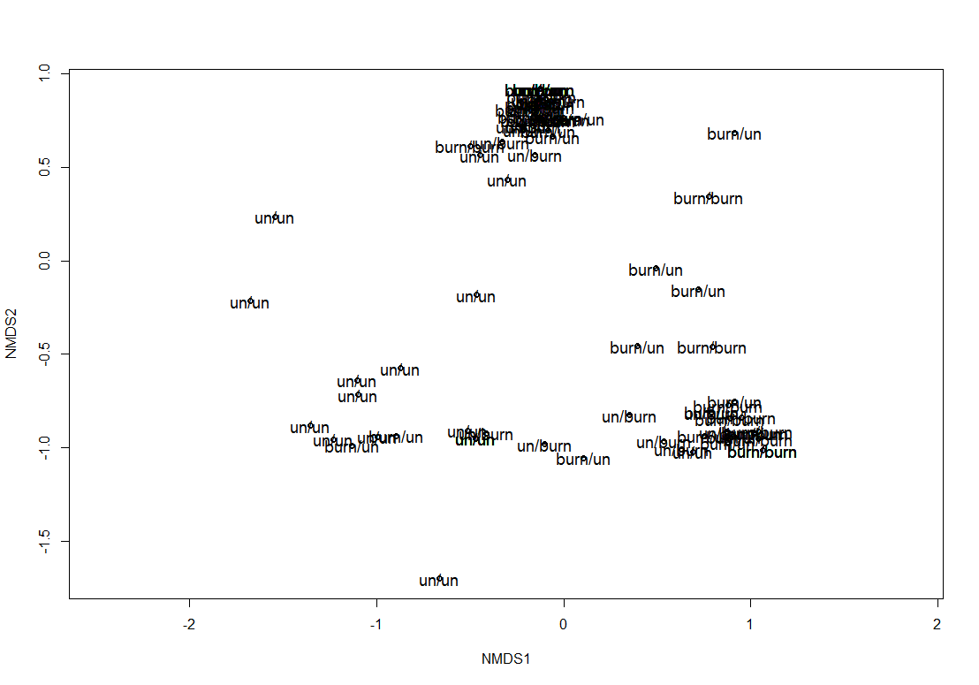

1,2,3 = low, 4=high

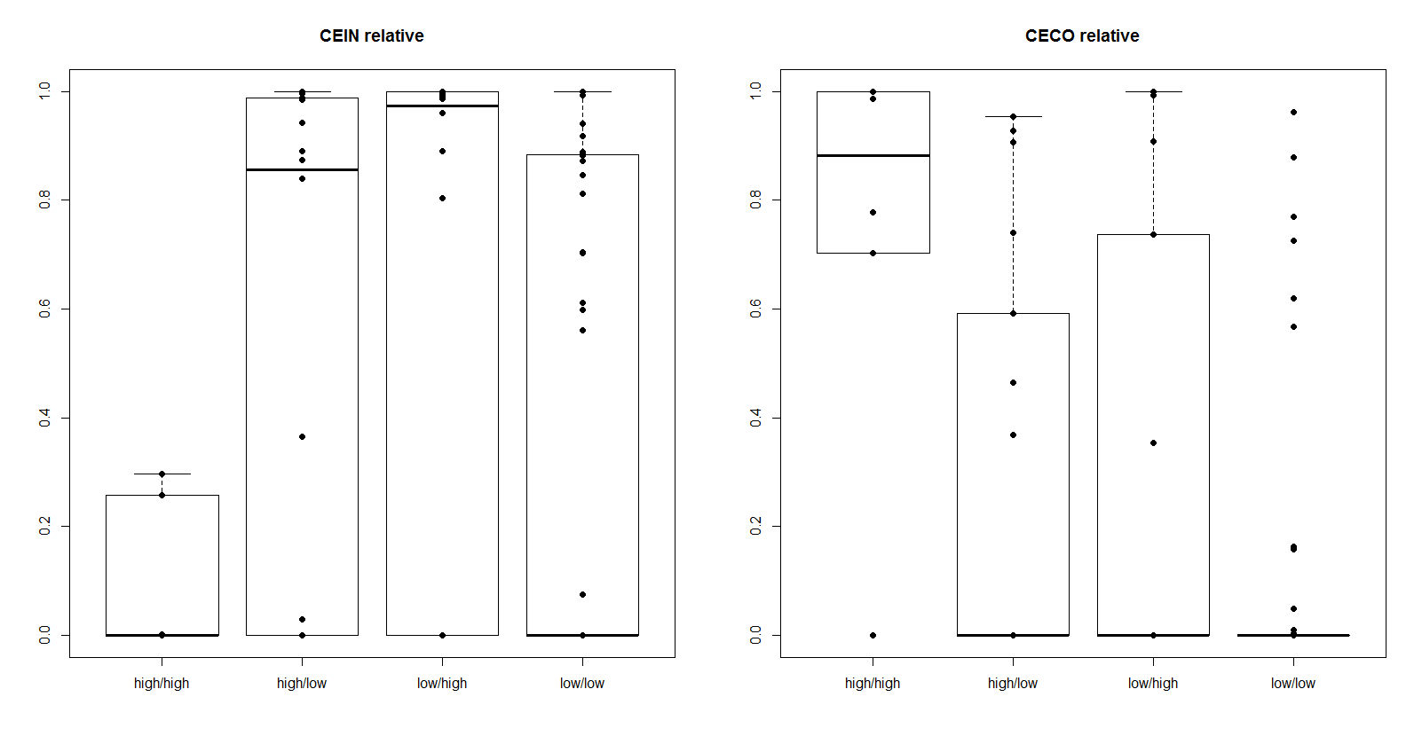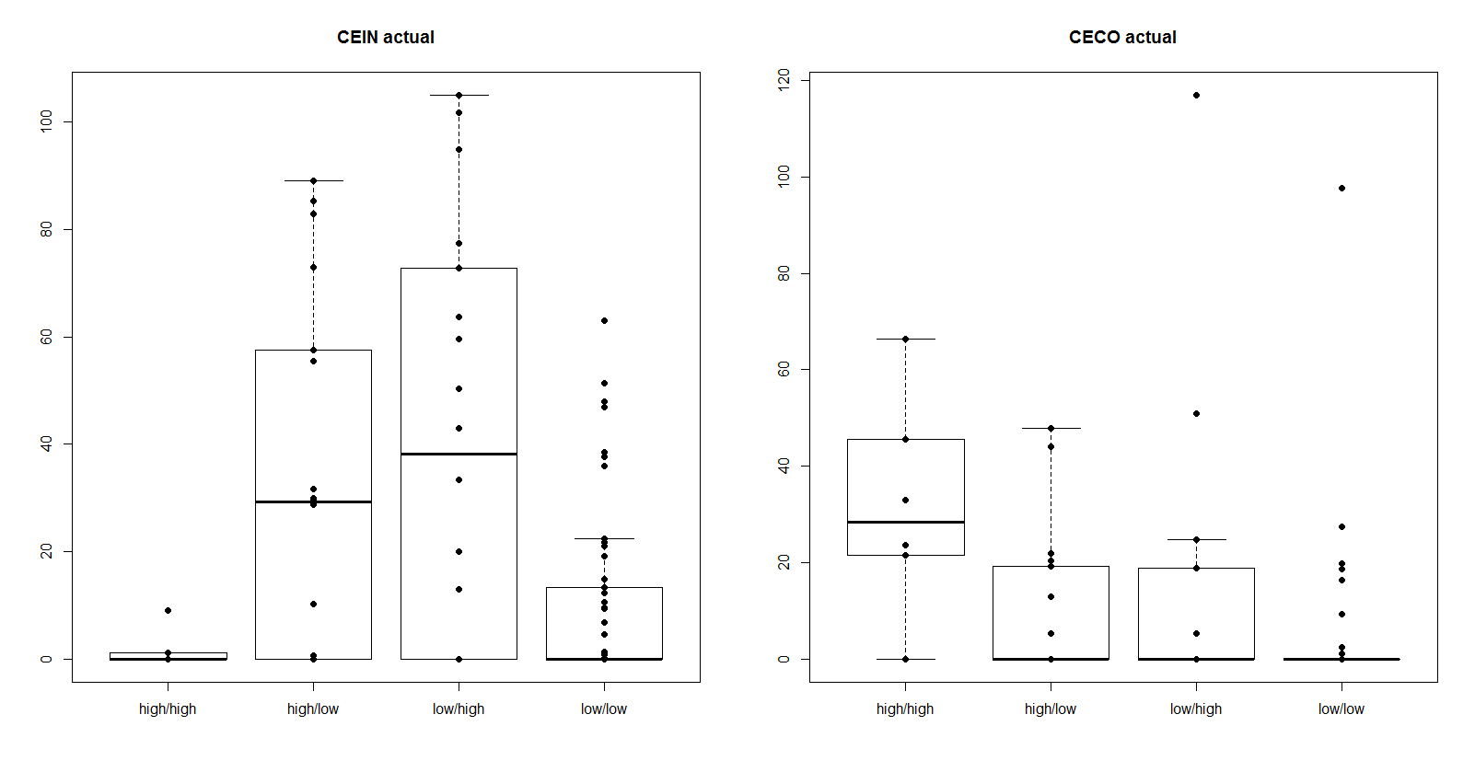

Fac. Sprouters (incl CECO). 1,2,3 = low, 4=high

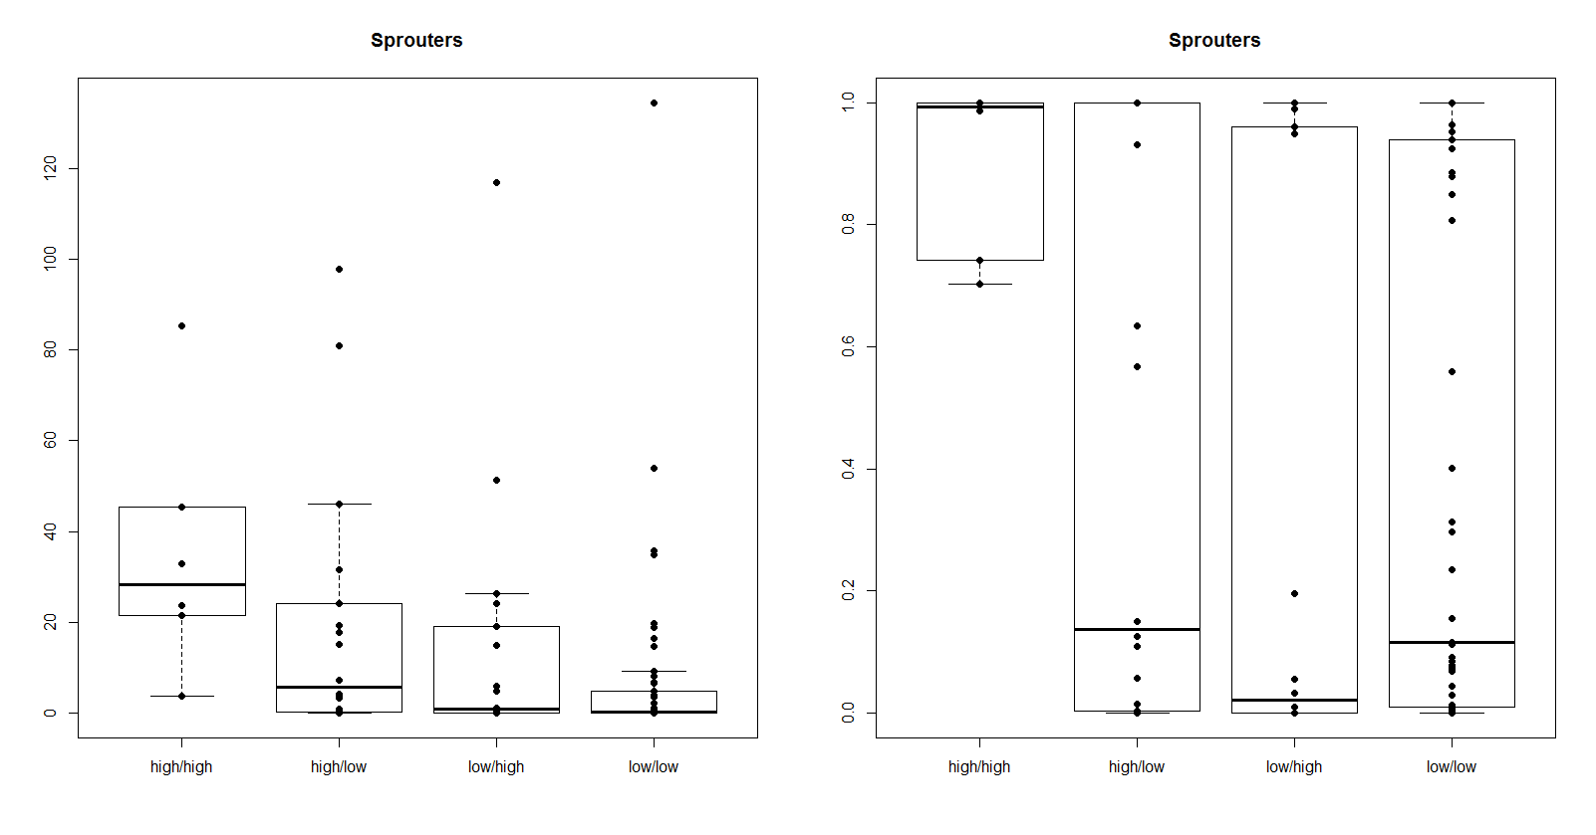

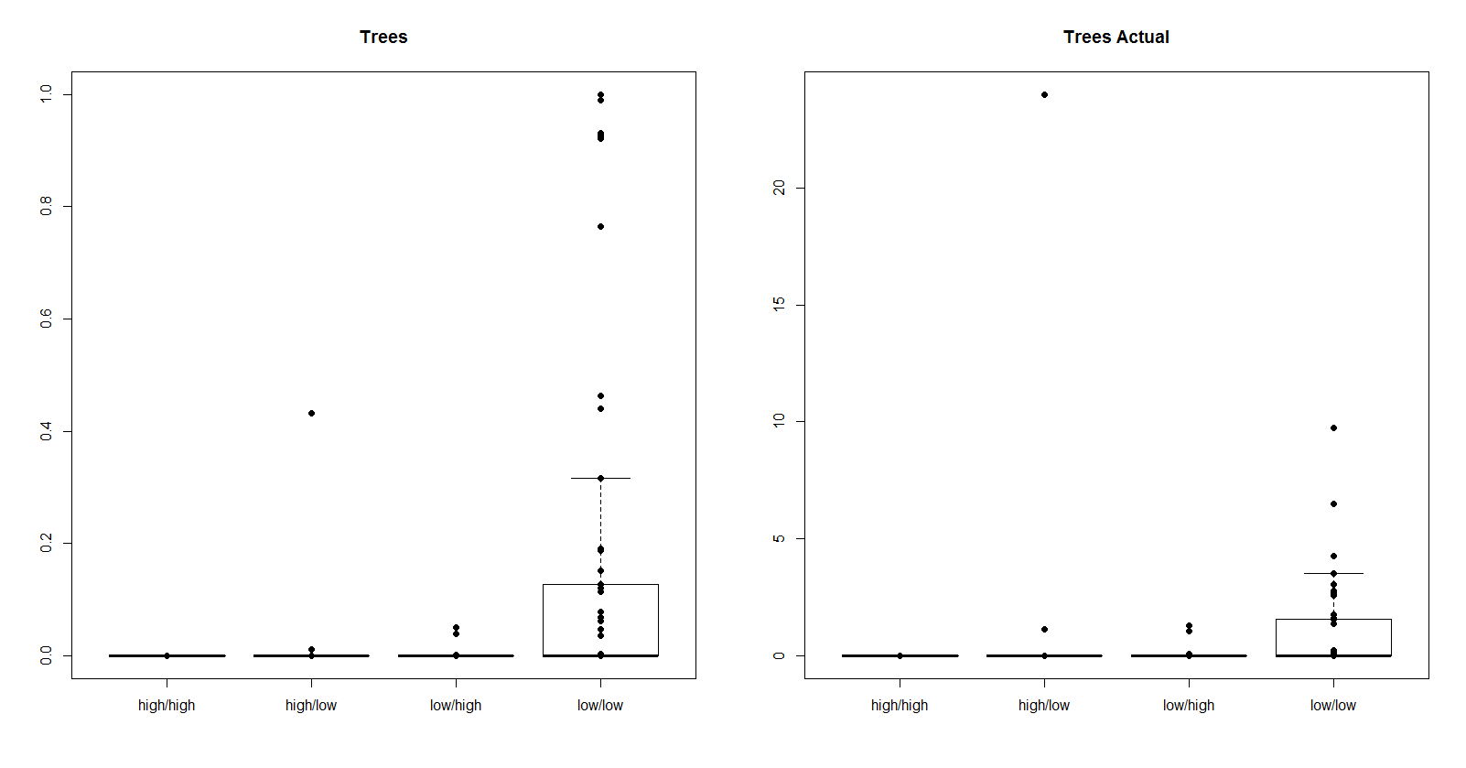

1=un, 2,3=low, 4=high

